GroupAssignment Mastery Assignment
Reflection Log
Stefan S
CSE 2110 Procedural Programming 1
(GroupAssignment.java)
How has your program changed from planning to coding to now? Explain.
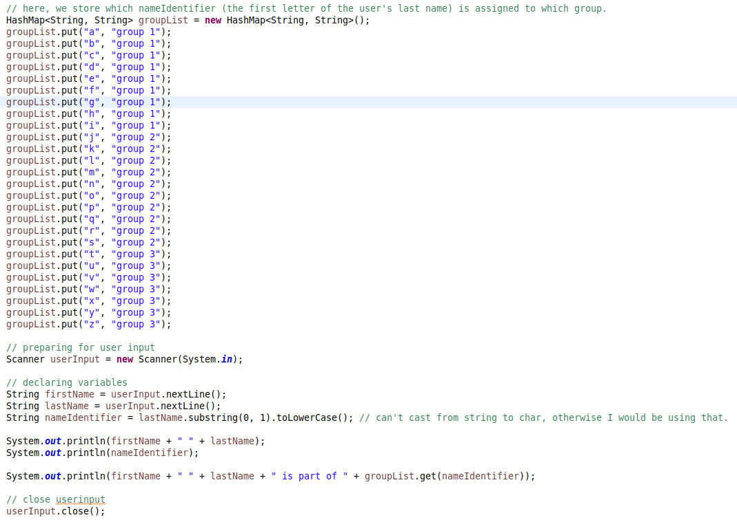
This is the first working version of my program. It deviates heavily from my IPO chart. Instead of writing if (nameIdentifier == a || nameIdentifier == b || nameIdentifier... repeatedly, I store the possible groups in a dictionary. A list of possible letters acts as the key, and the resulting group is the value. We fetch the value based on our nameIdentifier which we determined earlier.

Past this point, the program did not change substantially. The final version of the program is a more refined version of the initial program:
